Serial Datalogger

Please report any bugs to: Niklas Karbach (nkarbach@students.uni-mainz.de)

# Installation:

Verify that Python and pip are installed on your system by typing the command “python --version” and “pip --version” in the terminal. This program was written for Python 3.10 but it may also work with different versions like 3.9. The source file of Python 3.10 is included in this .zip file if Python is not already installed or the program does not work with the version that is currently installed on your system.

If pip is not installed, you can try executing “sudo python -m ensurepip --upgrade”. After executing this command, try “pip --version” again.

To install the program simply move the program file and the libraries (“SerialProgram.py”, “pyserial-3.5.tar.gz”, “keyboard-0.13.5.zip”) to the home folder of the user that you are currently using.

On “Raspberry Pi OS” this is typically the user “pi” and the home folder therefore is: “*/home/pi*”. Just move the program file to this folder.

The folder should now look something like this:

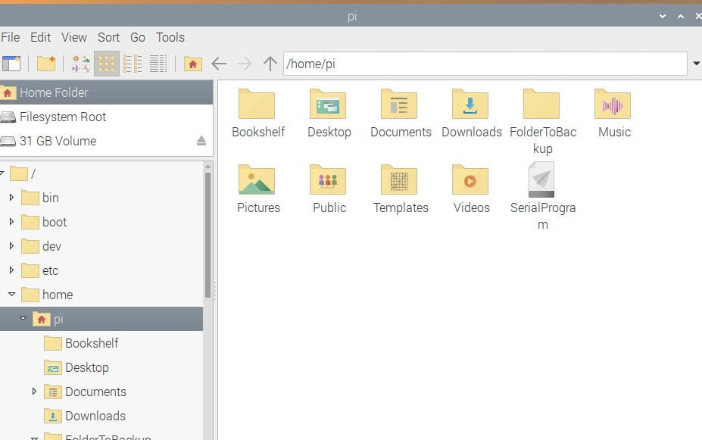

Then open the terminal and install the libraries via “sudo pip install pyserial-3.5.tar.gz” and “sudo pip install keyboard-0.13.5.zip”. After installing the libraries, you can delete the library files.

# Start the program:

To start the program **first connect** the device to a USB port

**and then** open the terminal and type:

“sudo python ./SerialProgram.py” and hit enter.

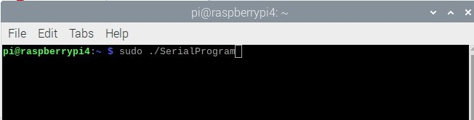

Note: If the program file is located in a different location than the home folder, specify the exact location. e.g.: “sudo python /home/pi/Desktop/SerialProgram.py” if the program is located on the Desktop.

After hitting enter, the program starts in the same terminal.

# Setup

Once the program is started, it asks the user to give information on the device that is connected. 1.) **Select the device from the list of available COM Ports.**

To select the device you want to log data from, you have to specify the COM Port that is going to be used. To specify the COM Port, you simply type in the name of the COM Port of the device you want to use and press enter. (The names of available COM Ports are listed)

e.g.: “/dev/ttyUSB0”

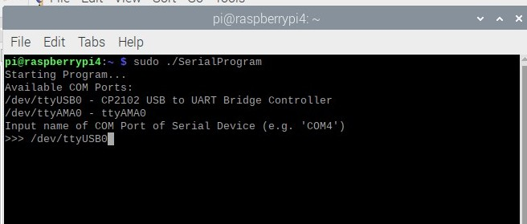

Note: You can identify the name of the device by first starting the program when the device is not connected, and then restarting the program when the device is connected. The device should only be listed when the device is actually connected via USB.

## 2.) Specify the baudrate of the connected device.

After the COM Port was specified, the program asks for the baudrate that is used. To specify the baudrate, you simply type in the baudrate and press enter.

(for an ESP32 the default baudrate is 115200; for an Arduino Uno the default baudrate is 9600)

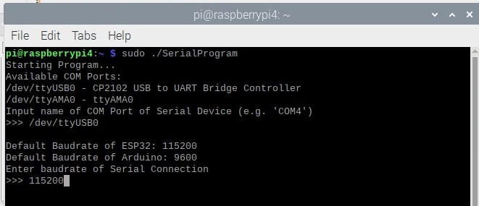

Note: It is crucial that you DO NOT use the NumPad to type in the numbers, otherwise the COM Port will not be opened!!!

Now you are in the main menu of the program!

# Start datalogging

## Logging without specifying a filename first:

You can directly start logging by typing “log” and pressing enter, a file with the current date and time as the filename will be created. All data that is read by the serial port will be automatically be saved in this file, which is located in the folder “/data” which is created in the home folder.

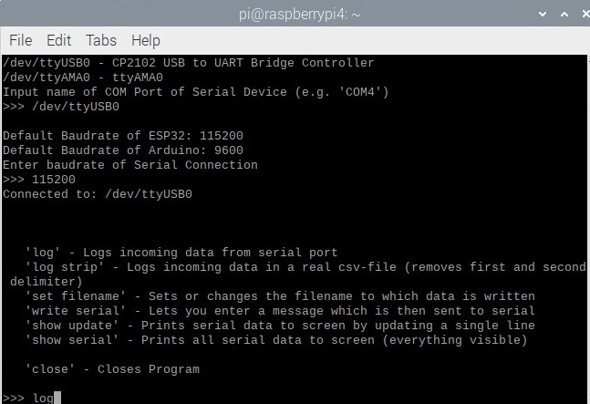

This command automatically creates the folder “/data” and logs all incoming data to a .txt file that created in the “/data” folder with the current date and time as the filename.

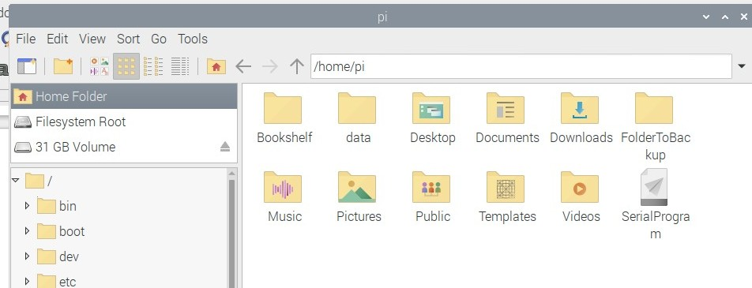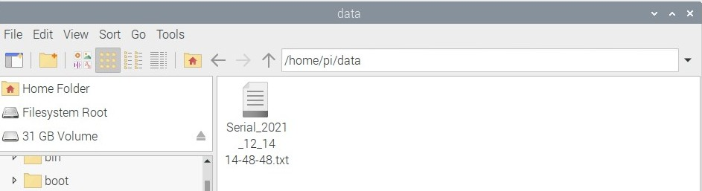

To stop datalogging you have to press “*q*” until the program shows “≫>” again, followed by Enter. This will bring you back to the main menu.

## Logging with specifying a filename:

When you set a filename by the command “set filename” first and then start logging, the filename of the logfile will be the one you specified. The file will be located in the same folder “/data”.

During this you will also be asked if you want to include a timestamp in the logfile. This is useful to later see, when the data was logged.

After those two inputs, you get back to the main menu.

Now to actually START datalogging, you type “log” and press enter. All incoming data will now be logged in the logfile with your custom filename which is located in the “/data” folder.

## Show the serial data without logging

To just show what is read on the serial connection, you can type either “show update” or “show serial”.

“show update” will only show the latest line of serial data that was received.

“show serial” will show everything that has been received.

To get back to the main menu, you have to press “*q*” until the program shows “≫>” again, followed by Enter.